**Computer Programming I**

**Essential Standard 3.00 Apply Procedures to Construct Windows Form  
Study Guide**

**3.01 Apply Controls Associated With Visual Studio Form (3%)**

1. What are the three ways to create a new project?
2. What are the four tools visible in the Visual Studio IDE? Identify them.  
   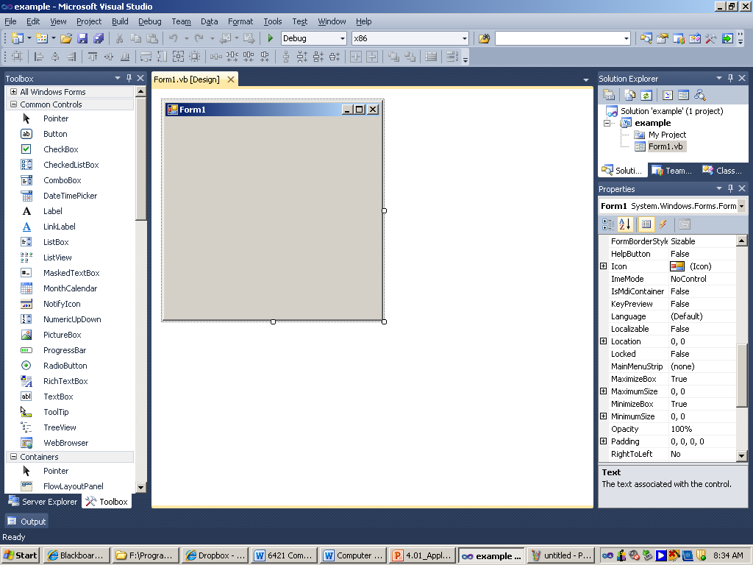
3. What is the Designer window?
4. What is the Editor window?
5. What is the Properties window?
6. What is the Toolbox?
7. How do you place a control object on your form?
8. Define these common control objects.
   1. Button
   2. TextBox
   3. Label
   4. ListBox
   5. ComboBox
   6. CheckBox
   7. RadioButton
   8. PictureBox

**3.02 Apply Properties Associated with the Controls (3%)**

1. What is a form?
2. How do you know if a control object is selected?
3. What are properties?
4. Define the Label control properties.
5. What is the syntax for displaying information in a label?
6. Write the statement to display “Study for your test” in the Label called lblMessage.
7. Modify #6 to have the message displayed on two lines as follows.  
    Study  
    for your test.
8. Define the Button control properties.
9. What type of event do we typically code for a button?
10. What are the two ways you can code a button click?
11. Define the CheckBox control properties.
12. What is a GroupBox?
13. Define the GroupBox control properties.
14. What events can you code for a CheckBox?
15. Define the RadioButton control properties.
16. How is a RadioButton different from a CheckBox?
17. What events can you code for a RadioButton?

**Know your code!**